RED TEAM 27
Capstone Security Assessment

Test 2: Idle Session Timeout Assessment
Brentwood Bank — Online Banking Portal
https://secure.myvirtualbranch.com/brentwoodbank/

Test conducted by
Pragya Mittal
Client Liaison & Security Architect

MSISPM Capstone — Carnegie Mellon University
April 8, 2026
CONFIDENTIAL

1. Executive Summary
This report documents the findings from Test 2 of the Red Team 27 capstone security assessment of Brentwood Bank’s online banking portal. The test evaluated the portal’s idle session timeout controls — specifically whether an authenticated session is terminated after a defined period of inactivity, and whether users receive adequate advance warning before that termination occurs.

The test was conducted using the OWASP ZAP proxy to capture network traffic during a live authenticated session. The tester logged in at 1:43 PM EDT and remained idle. At 2:02 PM EDT (approximately 19 minutes after login), a session expiry warning dialog appeared indicating the session would expire at 2:04 PM EDT. The session was not extended, and logout occurred as indicated at 2:04 PM, confirmed by the redirect to the logout page in proxy traffic.

Key findings: The portal implements an idle session timeout of approximately 21 minutes with a 2-minute advance warning dialog (LOW severity). This timeout duration slightly exceeds the FFIEC-recommended maximum of 15–20 minutes for online banking portals. The warning mechanism and forced logout functioned correctly. No critical defects were identified in the timeout implementation itself, though the timeout threshold represents a minor policy gap relative to federal guidance.

2. Test Environment
Parameter | Value
Date | April 8, 2026
Tester | Pragya Mittal — Client Liaison & Security Architect
Device | Dell Inc. Dell 14 Plus DB14250 (32 GB RAM)
OS | Ubuntu 24.04.4 LTS
Display | 2560 x 1600
Locale / Timezone | en-US / EDT
Capture Tool | OWASP ZAP (Proxy mode)
Target URL | https://secure.myvirtualbranch.com/brentwoodbank/
Browser | Firefox (standard window)
Login Time | 1:43:08 PM EDT
Warning Displayed | 2:02:02 PM EDT
Session Expired | 2:04:41 PM EDT

3. Scope & Objectives

3.1 Scope
This test was scoped to the authenticated online banking portal at secure.myvirtualbranch.com/brentwoodbank/. The test evaluated only passive session timeout behavior — no active exploitation, injection, or manipulation of network traffic was performed. The session was established using the tester’s legitimately opened Brentwood Bank account.

3.2 Objectives
This test was designed to determine:
- Whether the portal enforces an idle session timeout that automatically terminates an authenticated session after a defined period of inactivity.
- The duration of the timeout window — i.e., how many minutes of inactivity are permitted before session termination.
- Whether users receive advance warning before their session is terminated, and how much lead time is provided.
- Whether the timeout behavior conforms to FFIEC guidance and general industry best practices for online banking applications.

4. Method

4.1 Test Name
Idle Session Timeout Verification

4.2 Test Steps
Step 1 — Proxy Setup: OWASP ZAP was launched and configured as an HTTP/S proxy. The browser was configured to route traffic through ZAP to enable full request/response capture.

Step 2 — Authentication: The tester navigated to https://secure.myvirtualbranch.com/brentwoodbank/SignIn.aspx and authenticated with valid credentials at 1:43 PM EDT. The successful login was confirmed by the redirect chain through PostLogin.aspx and LoginRSA.aspx to the Account Summary page (React/Accounts.aspx), as captured in ZAP proxy entries #5, #18, #20, #24, and #26.

Step 3 — Induced Inactivity: After confirming successful login and verifying that the Account Summary page loaded fully, the tester ceased all browser interaction. No mouse movements, keystrokes, page navigations, or API calls were initiated by the tester.

Step 4 — Observation: The tester monitored the browser for session warning dialogs or automatic redirects while ZAP continued passively logging all background network traffic.

Step 5 — Warning Observed: At 2:02 PM EDT, the portal displayed a session expiry warning dialog reading: “If you would like to stay logged in, click OK. We will log you out if we don’t hear from you by 2:04 PM.”(Figure 1) The tester did not click OK or Cancel.

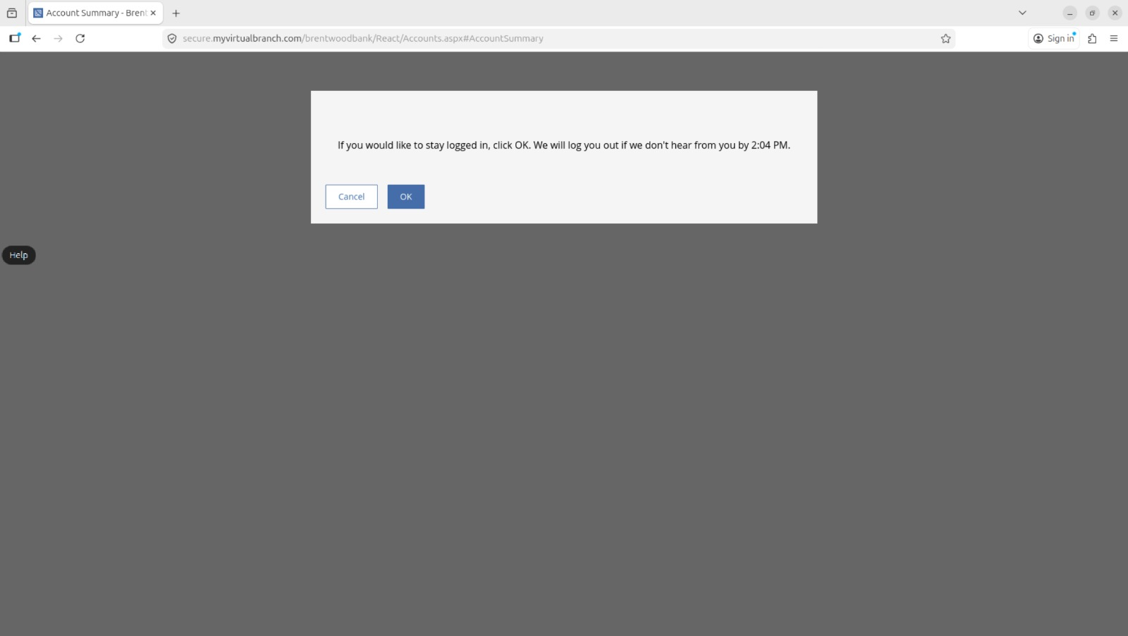
Figure 1: Session Expiration Warning Popup

Step 6 — Timeout Confirmation: At 2:04 PM EDT, the session was automatically terminated. ZAP captured the logout event as a GET request to https://secure.myvirtualbranch.com/brentwoodbank/logout.aspx?LogoutReason=SessionExpired (proxy entry #127), followed by a redirect to the public-facing bank homepage (www.brentwoodbank.com).

5. Findings

5.1 Idle Timeout Implemented
Result: PASS — Timeout functions correctly. The portal enforced an idle session timeout and logged the user out automatically after approximately 20 minutes of inactivity. The forced logout was confirmed by the ZAP-captured redirect to logout.aspx?LogoutReason=SessionExpired at 2:04 PM EDT.

5.2 Advance Warning Provided
Result: PASS — Warning dialog displayed. A session expiry warning dialog was presented to the user approximately 2 minutes before session termination (at 2:02 PM, with expiry at 2:04 PM). The dialog correctly identified the exact logout time and provided Cancel/OK options.

5.3 Timeout Duration — Policy Gap
Finding F-01: Idle Timeout Threshold Slightly Exceeds Recommended Maximum (LOW)

The observed idle timeout duration was approximately 21 minutes (login at 1:43 PM, forced logout at 2:04 PM). FFIEC guidance and NIST SP 800-63B recommend a maximum idle session timeout of 15–20 minutes for applications handling sensitive financial data. The portal’s 21-minute timeout falls outside the lower end of this recommended range.

Parameter | Observed Value | Recommended / Guidance
Login time | 1:43 PM EDT | —
Warning dialog time | 2:02 PM EDT | —
Session expiry time | 2:04 PM EDT | —
Total idle window | ~21 minutes | ≤20 minutes (FFIEC)
Warning lead time | ~2 minutes | ≥2 minutes (common practice)
Logout confirmed via | logout.aspx?LogoutReason=SessionExpired | —

6. Assessment
The Brentwood Bank online banking portal implements a functional idle session timeout mechanism with user-facing advance warning. The core control is operating as designed: unauthenticated users cannot maintain an open session indefinitely, and users are given reasonable notice before automatic logout.

However, the 21-minute timeout window modestly exceeds the upper boundary of the FFIEC-recommended 15–20 minute range for online banking applications. While this 1-minute overage is unlikely to represent a material risk in isolation, it represents a minor deviation from federal examination guidance. In an adversarial scenario, a 21-minute window provides slightly more opportunity for session hijacking or unauthorized access from an unattended workstation compared to a 15-minute configuration.

The 2-minute advance warning is appropriate and functional. The dialog language is clear and actionable, correctly communicating the logout deadline in human-readable format.

Overall risk rating: LOW. The timeout is implemented and functioning. The finding is a policy calibration issue rather than a security control failure.

7. Recommendations
# | Recommendation | Priority | Detail
R-01 | Reduce idle timeout threshold to 15 minutes | LOW | Adjust the session inactivity timeout from ~21 minutes to 15 minutes to align with FFIEC guidance and NIST SP 800-63B for online banking applications.
R-02 | Consider extending the pre-expiry warning window | INFORMATIONAL | The current 2-minute warning window is functional, but a 5-minute warning is more user-friendly for customers who may not be actively watching the screen. This is especially relevant if R-01 is implemented and the overall window is reduced.
R-03 | Review timeout policy documentation | INFORMATIONAL | Ensure the timeout duration is formally documented in Brentwood Bank’s security policy and reconciled with the bank’s FFIEC IT examination posture to avoid findings in future audits.

End of Test 2 Report — Red Team 27

